OHIO SMALL POLICE DEPARTMENT ASSOCIATION
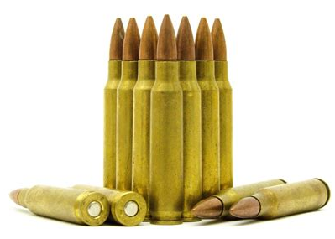
AMMO RAFFLE
Remington
1000 Centerfire Cartridges
223 REM 55 GR FMJ

CCI/SPEER
1000 Centerfire Cartridges
9MM LUGER 115GR FMJ

$5 per ticket OR 5 Tickets for $20
TWO (2) drawings to be held online
July 4th, 2022
FOR TICKETS: WWW.OSPDA.ORG and click “DONATION”
Be sure to include your name and phone number so we can send you a picture of your stubs!!
OR TEXT: 440-822-6330 (DENISE) OR 912-227-4440 (JEFF)
*WE WILL CALL THE WINNER AND POST THE DRAWING ONLINE (FACEBOOK & WEBSITE)*

